# **Problems #36 to #40**

==================================

# **Problem 36**

======================

Description:Write A Program: Simple Calculator

==================================

#include <iostream>

using namespace std;

enum enOperationType{ Add = '+', Subtract = '-',Multiply = '*', Divide = '/'};

float ReadNumber(string Message){

float Number = 0;

cout<<Message<<endl;

cin>> Number;

return Number;

}

enOperationType ReadOPType(){

char OT = '+';

cout<<"Please Enter Operation Type(+, -, *, /): \n";

cin>> OT;

return (enOperationType)OT;

}

float Calculate(float Number1, float Number2,enOperationType OPType){

switch(OPType){

case enOperationType::Add:

return Number1 + Number2;

case enOperationType::Subtract:

return Number1 - Number2;

case enOperationType::Multiply:

return Number1 * Number2;

case enOperationType::Divide:

return Number1 / Number2;

default:

return Number1 + Number2;

}

}

int main(){

float Number1 = ReadNumber("Enter Number 1: ");

float Number2 = ReadNumber("Enter Number 2: ");

enOperationType OpType = ReadOPType();

cout<<endl<<"Result = "<<Calculate(Number1, Number2,OpType)<<endl;

return 0;

}

=====================================================================

The Output:

=========

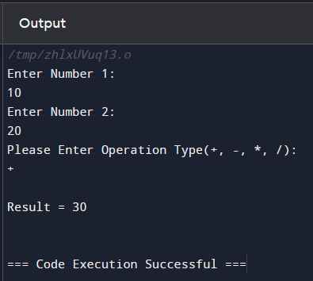

=====================================================================

# **Problem 37**

===================

Description: Write A Program: Sum until -99

=================================

#include <iostream>

#include <string>

using namespace std;

float ReadNumber(string Message){

float Number = 0;

cout<<Message<<endl;

cin>> Number;

return Number;

}

float SumNumbers(){

int Sum = 0, Number = 0, Counter = 1;

do{

Number = ReadNumber("Please Enter Number: ");

if(Number == -99){

break;

}

Sum += Number;

Counter ++;

}while(Number != -99);

return Sum;

}

int main(){

cout<<endl<<"Result = "<<SumNumbers()<<endl;

return 0;

}

=====================================================================

The output:

=========================

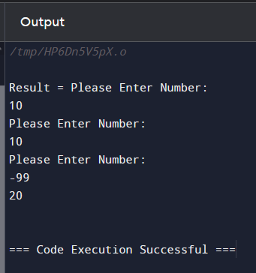

=====================================================================

# **Problem 38**

=========================

Description: Write A Program: Prime Number

==================================

#include <iostream>

#include <math.h>

using namespace std;

enum enPrimeNotPrime { Prime = 1, Notprime = 2};

float ReadpositiveNumber(string Message){

float Number = 0;

do{

cout<<Message<<endl;

cin>> Number;

}while(Number <= 0);

return Number;

}

enPrimeNotPrime CheckPrime(int Number){

int M = round(Number / 2);

for(int Counter = 2; Counter <= M; Counter++){

if(Number % Counter == 0)

return enPrimeNotPrime::Notprime;

}

return enPrimeNotPrime::Prime;

}

void PrintNumberType(int Number){

switch(CheckPrime(Number)){

case enPrimeNotPrime::Prime:

cout<<"\nThe Number Is Prime\n";

break;

case enPrimeNotPrime::Notprime:

cout<<"\nThe Number Not Prime\n";

break;

}

}

int main(){

PrintNumberType(ReadpositiveNumber("Please Enter A Positive Number: "));

return 0;

}

========================================================================

The Output:

=============

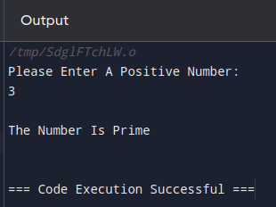

========================================================================

# **Problem 39**

=======================

Description: Write A program: Pay Remainder

====================================

#include <iostream>

#include <math.h>

using namespace std;

float ReadpositiveNumber(string Message){

float Number = 0;

do{

cout<<Message<<endl;

cin>> Number;

}while(Number <= 0);

return Number;

}

float CalculateRemainder(float TotalBill, float TotalPaidcash){

return TotalBill - TotalPaidcash;

}

int main(){

float TotalBill = ReadpositiveNumber("Enter Total Bill: ");

float TotalCashPaid = ReadpositiveNumber("Enter Total Cash Paid: ");

cout<<endl;

cout<<"Total Bill = "<<TotalBill<<endl;

cout<<"Total Paid Cash = "<<TotalCashPaid<<endl;

cout<<"****************\n";

cout<<CalculateRemainder(TotalBill,TotalCashPaid);

return 0;

}

========================================================================

The output:

===========

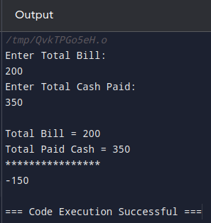

========================================================================

# **Problem 40**

======================

Description: Write A Program: Service Fee And Sales Tax;

================================================

#include <iostream>

#include <math.h>

using namespace std;

float ReadpositiveNumber(string Message){

float Number = 0;

do{

cout<<Message<<endl;

cin>> Number;

}while(Number <= 0);

return Number;

}

float TotalBillAfterServiceAndTax(float TotalBill){

TotalBill *= 1.1;

TotalBill *= 1.16;

return TotalBill;

}

int main(){

float TotalBill = ReadpositiveNumber("Enter Total Bill: ");

cout<<endl;

cout<<"Total Bill = "<<TotalBill<<endl;

cout<<"Total Bill After Service Fee And Sales Tax = "<<

TotalBillAfterServiceAndTax(TotalBill)<<endl;

cout<<"****************\n";

return 0;

}

========================================================================

The Output:

=============



